An Evaluation of Encryption Schemes that can Mitigate Data Breaches on Cloud-based Systems

Gabriel Ruggie
Department of Electrical and Computer Engineering
University of Wisconsin-Madison

InterEGR 397
Dr. Tom McGlamery
December 17th, 2023

Work Cited
[1] 2022 Healthcare Data Breach Report - HIPAA Journal. (n.d.). https://www.hipaajournal.com/2022-healthcare-data-breach-report/
[2] Asymmetric encryption: Definition, architecture, usage. Employee and Customer Identity Solutions. (n.d.). https://www.okta.com/identity-101/asymmetric-encryption/
[3] Bitpanda. (n.d.). What is asymmetric encryption?. - Bitpanda Academy. https://www.bitpanda.com/academy/en/lessons/what-is-asymmetric-encryption/
[4] Brush, K., Rosencrance, L., & Cobb, M. (2021, September 27). What is asymmetric cryptography? definition from searchsecurity. Security. https://www.techtarget.com/searchsecurity/definition/asymmetric-cryptography
[5] Case, M. (n.d.). (rep.). A Beginner’s Guide to The General Number Field Sieve. Oregon State University.
[6] Cordova, R. S., Maata, R. L. R., Halibas, A. S., & Al-Azawi, R. (2017). (tech.). Comparative Analysis on the Performance of Selected Algorithms in Cloud Computing (pp. 1–4). ICECTA.
[7] Elliptic curve cryptography (ECC). Elliptic Curve Cryptography (ECC) - Practical Cryptography for Developers. (n.d.). https://cryptobook.nakov.com/asymmetric-key-ciphers/elliptic-curve-cryptography-ecc
[8] Elliptic curve cryptography: Breaking security and a comparison with RSA. Andrea Corbellini Atom. (n.d.). https://andrea.corbellini.name/2015/06/08/elliptic-curve-cryptography-breaking-security-and-a-comparison-with-rsa/
[9] Gadad, A., & Anbusezhiyan, D. (2023). (rep.). Cloud security: literature survey (pp. 4734–2742). IJECE.
[10] Gajra, N., Khan, S. S., & Rane, P. (2014). (tech.). Private Cloud Security: Secured user Authentication by using Enhanced Hybrid Algorithm (pp. 1–6). IEEE.
[11] Graphing calculator. Desmos. (n.d.). https://www.desmos.com/calculator
[12] Herold, R. (2020, March 21). Top 4 reasons encryption is not used. Privacy and Security Brainiacs. https://privacysecuritybrainiacs.com/privacy-professor-blog/top-four-reasons-encryption-is-not-used/
[13] IBM Security. (2022). (rep.). Cost of Data Breach Report 2022 (pp. 1–59). Armonk, New York: IBM Corporation.
[14] Just, J., & Coffey, J. An Assessment of Attacks Strategies on the RSA Public-Key Cryptosystem.
[15] Office of Justice Programs, & Harrell, E., Victims of Identity Theft, 2018 1–29 (2021). Washington DC; Bureau of Justice Statistics.
[16] Pandey, K., & Sharma, D. (2023). (rep.). Advances in Data Security Through Elliptical Curve Cryptography (pp. 1–7). Raipur, India: AIP Publishing.
[17] Peter Smirnoff & Dawn M. Turner (guests). (2023, March 14). Symmetric key encryption - why, where and how it’s used in banking. Secure Cryptographic Solutions. https://www.cryptomathic.com/news-events/blog/symmetric-key-encryption-why-where-and-how-its-used-in-banking
[18] Pharkkavi, D., & Maruthanayagam, D. (2018). Time Complexity Analysis of RSA and ECC
Based Security Algorithms in Cloud Data. International Journal of Advanced Research in Computer Science, 9(3) https://doi.org/http://dx.doi.org/10.26483/ijarcs.v9i3.6104
[19] Preez, P. P. du. (2020, October 6). Understanding EC Diffie-Hellman. Medium. https://medium.com/swlh/understanding-ec-diffie-hellman-9c07be338d4a
[20] Sharma, S., & Pokharana, A. (2021). (tech.). Comparative Analysis of AES-ECC and AES-ECDH Hybrid Models for a Client-Server System (pp. 1–7). Bangalore, India: GCAT.
[21] Smart, N. The Discrete Logarithm Problem on Elliptic Curves of Trace One. J. Cryptology 12,
193–196 (1999). https://doi.org/10.1007/s001459900052
[22] Stevenhagen, P. (2008). (tech.). The number field sieve (Vol. 44, pp. 1–18). The Netherlands: MSRI.
[23] Sullivan, N., Kwiatkowski, K., Faz-Hernández, A., Grant, D., Krasnov, V., & Graham-Cumming, J. (2023, October 24). A (relatively easy to understand) primer on elliptic curve cryptography. The Cloudflare Blog. https://blog.cloudflare.com/a-relatively-easy-to-understand-primer-on-elliptic-curve-cryptography/
[24] Team, D. (2023, August 7). Secure Key Management Strategies in cryptography. Daisie Blog. https://blog.daisie.com/secure-key-management-strategies-in-cryptography/#:~:text=Use%20Hardware%20Security%20Modules%20(HSMs,securely%20and%20prevent%20unauthorized%20access.
[25] The Thales Group. (n.d.). (rep.). 2023 Cloud Security Study: Global Edition (pp. 1–17). The Thales Group.
[26] Varma, C. (2018). (tech.). A Study of the ECC, RSA, and the Diffie-Hellman Algorithms in
Network Security. Coimbatore, India: IEEE.
[27] Verma, S. K., & Ojha, D. B. (2012). (rep.). A Discussion on Elliptic Curve Cryptography and Its Applications (1st ed., Vol. 9, pp. 74–77). Ghaziabad, India: IJCSI.
[28] Wikimedia Foundation. (2023d, December 16). Diffie–Hellman Key Exchange. Wikipedia. https://en.wikipedia.org/wiki/Diffie%E2%80%93Hellman_key_exchange
[29] Wikimedia Foundation. (2023, October 24). Discrete logarithm. Wikipedia. https://en.wikipedia.org/wiki/Discrete_logarithm
[30] Wikimedia Foundation. (2023b, November 28). Integer Factorization Records. Wikipedia. https://en.wikipedia.org/wiki/Integer_factorization_records#:~:text=The%20663%2Dbit%20(200%2D,by%20Franke%2C%20Kleinjung%20et%20al.
[31] Wikimedia Foundation. (2023c, December 3). Symmetric-key algorithm. Wikipedia. https://en.wikipedia.org/wiki/Symmetric-key_algorithm
[32] Wikimedia Foundation. (2023b, December 6). General Number Field Sieve. Wikipedia. https://en.wikipedia.org/wiki/General_number_field_sieve
[33] Wikimedia Foundation. (2023d, December 12). RSA (cryptosystem). Wikipedia. https://en.wikipedia.org/wiki/RSA_(cryptosystem)
[34] Yellamma, P., Narasimham, C., & Sreenivas, V. (2023). (rep.). Data Security in Cloud Using RSA (pp. 1–6). New York City, NY: IEEE.

Table of Contents

Work Cited……………………………………………………………………………………..2
Executive Summary …………………………………………………………………………...6
1. Introduction & Project Significance………………………………………………………...8
2. Technical Background………………………………………………………………………9
2.1 Symmetric Encryption Overview………………………………………………….9
2.2 Asymmetric Encryption & The Rivest-Shamir-Adleman (RSA) Algorithm……...10
2.3 Key Exchange Algorithms in Cryptography………………………………………13
2.4 An Overview of Elliptical Curves…………………………………………………14
2.5 The Elliptical Curve Diffie-Hellman Key Exchange Algorithm (ECDH)………...17
3. Comparative Analysis of ECDH & RSA…………………………………………………...18
4. Factorization Attacks on RSA………………………………………………………………21
5. Breaking Elliptical Curves: The Discrete Logarithm Problem……………………………..22
6. Conclusion…………………………………………………………………………………..24
Glossary………………………………………………………………………………………..25

Executive Summary

In this report, I will compare two encryption algorithms, RSA and ECDH, with the goal of recommending one to be used to mitigate data breaches on cloud-based systems.

In 2022, the average cost of a data breach in the United States was found to be $9.44 million. In that same year, 457 companies were attacked more than once and as a result, 330 had to increase the price of their products and services. The increased frequency of these breaches makes it necessary for companies to implement stronger security. Current and developing strategies employed to enhance security, such as multi-factor authentication, a more complex checks-and-balances security hierarchy and an increase in security audits are steps in the right direction. Encryption, however, can directly lock the data instead of making it less accessible.

Rivest-Shamir-Adleman (RSA) is an asymmetric encryption algorithm, meaning a public key is generated for encryption and a separate private key is generated for decryption. The algorithm is easy to learn and implement which is one of the qualities that makes it so popular with many cryptographers. This is unlike Elliptical Curve Diffie-Hellman (ECDH) which is far more difficult to understand and use because of its use of elliptical curves.

ECDH is a key exchange algorithm. It can encrypt data, but it is primarily used in combination with a symmetric encryption algorithm because symmetric encryption schemes only use one key for both encryption and decryption; therefore, sharing the key with authenticated personnel is a more complicated process.

When comparing these algorithms, the key sizes necessary for each tells most of the story. RSA needs much larger public and private keys than ECDH. Therefore, RSA requires higher computing power, allocates more memory and is overall slower on all significant operations. ECDH requires minimal key sizes and when compared to other elliptical curve-based algorithms, it competes in speed and comes out on top in space complexity.

Key Size Comparison (Bits) | Key Generation + Encryption + Decryption  Time Comparison (ms)
  ECDH | RSA
  128 | 1024
  160 | 2048
  192 | 3072
  224 | 7680
  256 | 15360
  Key Size (Bits)  RSA: ECDH | RSA | ECDH
  1024: 128 | 110.99 | 91.11
  2048: 160 | 154.5 | 107.66
  3078: 192 | 194.04 | 120.26
  7680: 224 | 218.5 | 166.86
  15360: 256 | 277.41 | 177.9

When evaluating an algorithm’s overall security, it is necessary to analyze the current methods utilized to break them. Factorization attacks are the most common method to break an RSA-based scheme with the General Number Field Sieve algorithm being the most effective. Factorization attacks work on factoring an element of the public key to derive the private key. This is precisely why RSA requires very large keys because longer numbers increase the amount of time necessary to factor them. In order to break ECDH, the discrete logarithm problem must be solved which is much more difficult and time-consuming than factoring numbers. While the General Number Field Sieve algorithm can break a 250-digit key, Pollard’s Rho, an algorithm used to break elliptical curve-based algorithms, can only crack 33-digits.

Although implementing RSA encryption would be a much more feasible option, I highly recommend ECDH as a long-term encryption strategy. Overcoming the challenge of implementing ECDH correctly would ultimately be a more cost-effective option because it necessitates less memory and computational power to function. Moreover, the inherent difficulty of the discrete logarithm problem enhances the security of ECDH and any system that utilizes it.

1. Introduction and Project Significance

Between the years 2009 and 2022, over 382 million health records containing sensitive data has been stolen through data breaches. [1] In a 2022 report by IBM, 83% of a surveyed 550 companies experienced more than one data breach that year. [13] In the same study, it was found that the United States had an average data breach cost of $9.44 million, the highest of any country in the world. Data is the most valuable thing in the world right now, and obtaining massive amounts of it has proven to be very lucrative for criminals. In 2018, 23 million people in the United States were affected by identity theft and about 71% of those victims incurred financial losses that totaled to $15.1 billion. [15]

From the moment we wake up, to the moment we go to bed, our data is being collected, stored and analyzed by millions of different companies. As more companies convert to cloud-based infrastructure, more of this data is pooled together which makes it a more desirable target for thieves. Data breaches are one of the most common methods of obtaining mass amounts of sensitive data and as they continue to become more frequent, methods and strategies are being developed to mitigate their damage. Some of these strategies include enhanced employee training, stronger security clearances, more frequent security audits and multi-factor authentication. [13, 25] While these methods do lower attack rate success, the data itself can be made inherently more secure through encryption.

Encryption is the act of converting plaintext into an unreadable file called a ciphertext. This encrypted information can only be accessed by decrypting the ciphertext with a unique key. [2] In early 2023, it was found that only 45% of sensitive data in the cloud is encrypted. [25] Many companies do not understand the value encryption brings and therefore allocate budget spending for more exciting projects such as Big Data analytics. [12]. Also, many executives view adding encryption as adding unnecessary complexity to their already large cloud infrastructure. [12] However, it has been found that companies that extensively use encryption save upwards of $720,000 in breach costs. [13]. These breaches are inevitable and encryption is one of the best options for long term security.

In my research, I will compare 2 fundamentally different encryption algorithms with the goal of recommending one to be implemented to secure cloud-based infrastructure. I will first give a basic, however informative, overview of each algorithm in order to aid in comprehension. I will then evaluate each algorithm based on a number of factors such as overall speed, memory consumption and difficulty of implementation. Finally, I will make a case as to why I believe the Elliptical Curve Diffie-Hellman encryption scheme should be implemented to mitigate data breaches on cloud-based systems.

2. Technical Background

2.1 Symmetric Encryption Overview
Symmetric encryption is a class of encryption where the same key is used for both encryption and decryption. [34] A symmetric encryption algorithm would generate this key and distribute it to all parties. Below, Figure 2.2.1 outlines the encryption-decryption process for symmetric algorithms.

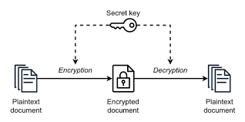

Figure 2.1.1 Schematic of Symmetric Encryption. A secret key is generated and distributed to all parties in order to provide both encryption and decryption functionality. [34]

Symmetric algorithms are typically used for securing large amounts of data as they are very fast and do not require heavy computational power. [2, 17] While these algorithms are ideal for securing large-scale databases, the problem of distributing the secret key must be solved in order to use any symmetric encryption scheme effectively. If an unsecure channel is used for key distribution, it becomes very easy for any malicious actors to intercept the key rendering the algorithm useless for security. [17, 24] However, setting up these secure channels comes with additional computing power, cost as well as another platform to continuously manage. Clearly, this is a major drawback of symmetric encryption and can be solved in two ways: using a key exchange algorithm on top of symmetric encryption or using an asymmetric encryption algorithm. The latter will be discussed next.

2.2 Asymmetric Encryption & The Rivest-Shamir-Adleman (RSA) Algorithm
Asymmetric encryption is a class of encryption where one key is used for encryption and another is used for decryption. [2] When an asymmetric algorithm is run, the public key, used for encryption, is distributed to all party members and the private key, used for decryption, is kept by authenticated personnel only. [33] Figure 2.1.1 illustrates the encryption-decryption process below.

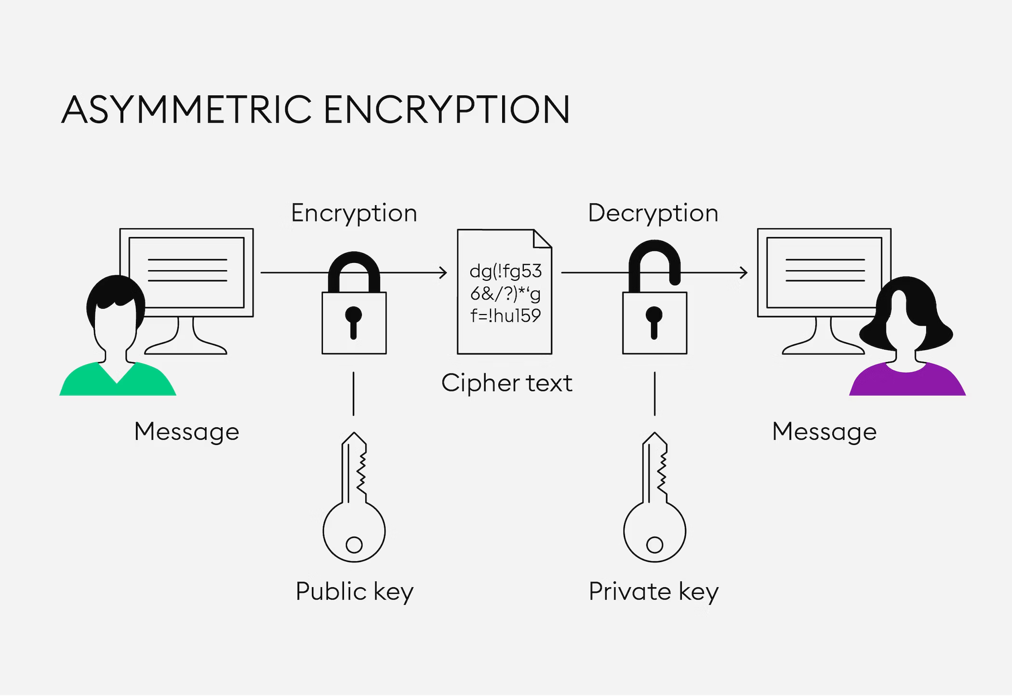
Figure 2.2.1. Schematic of Asymmetric Encryption. The public and private key are both generated when the algorithm is initially run. The public key is used for encryption and is visible to everyone, while the private key is used for decryption and is kept secured by authenticated individuals. [3]

The generation of separate keys solves the key distribution problem because in order to obtain the private key, one would just need to run the algorithm locally instead of trying to have it shared with them. This is also why asymmetric encryption algorithms are safer and easier to use compared to symmetric algorithms.

The Rivest-Shamir-Adleman (RSA) encryption algorithm is one of the best asymmetric encryption algorithms in use today and was introduced by Ron Rivest, Adi Shamir and Leonard Adleman back in 1977. [33] A major draw of RSA is that is easy to understand and implement its key generation, encryption and decryption methods. In order to quickly comprehend the algorithm, I will walk through an example of generating the public and private keys then demonstrate how they encrypt and decrypt a message.

To start the key generation process, I will choose two prime numbers, p and q, at random and multiply them to get a third number n. Let p = 2 and q = 5, then n = 10. The next step is to use equation 2.2.1 to find phi(n). [18]

$$ϕ\left(n\right)=(p-1)(q-1)$$
Equation 2.2.1 [18]

Having calculated phi(n) to be 4, we now can choose a value e, which will be our encryption number. e must be greater than 1, less than phi(n), and be a coprime with both phi(n) and n. For two numbers to be coprime, they must only have a common factor of 1. Therefore, the only possible value for e is 3. [18]

The last step is to calculate our decryption number d. For this, we apply equation 2.2.2, shown below. Essentially, we must pick a value for d such that when we divide 3d by phi(n), the remainder is 1. This is what the mod operation means and it is short for modulus. [18]

$$de mod ϕ\left(n\right)=1$$
Equation 2.2.2 [18]

Understand that there are multiple values for d which would make equation 2.2.2 be true. In my case, I have decided to let d = 11. In a reality, it is good practice to never choose the first value of d that works because this is easier to obtain in a brute force context. This concludes the key generation process of RSA where the public key is the pair (e, n) and the private key is the pair (d, n).

Let “a” be a message I want to encrypt. I must first, map “a” to an integer. For the sake of simplicity, let’s assume “a” maps to 2. Then, using equation 2.2.3 below, I can encrypt my message m which is now equal to 2. [18]

$$m^{e }mod n$$
Equation 2.2.3 [18]

When we apply our known values for m, e and n, the output is 8 which we can map to an example message “d”. “d” is the ciphertext that is passed to the recipient. Once the ciphertext is received, equation 2.2.3 is applied to decrypt the message however, e is replaced with d. [18]

$$8^{11}=8589934592$$
$$8589934592 mod 10 ≈2$$

Observe that we obtain 2 which we originally mapped “a” to. Therefore, we have successfully generated a private and public key and used them to encrypt and decrypt a message. In reality, d, e and n are hundreds of digits long in order to provide high level security. That being said, the encryption-decryption processes are exactly as demonstrated and their simplicity is what makes RSA a very desirable algorithm to use. Notice, there was no added step of sharing a private key and possibly compromising the entire operation. It was assumed that the individual wishing to accept a message, ran the algorithm and kept the private key while distributing the public key.

Although asymmetric encryption algorithms such as RSA are naturally more secure than symmetric encryption algorithms, the added complexity of generating two functionally different keys means more computing power is needed and makes it slower to use. [2] Decrypting mass amounts of data will take longer using an asymmetric algorithm compared to a symmetric algorithm and a more in-depth analysis into speed, memory consumption and implementation complexity is discussed in section 3. Still, RSA is an excellent encryption algorithm and is widely used in many security systems today.

2.3 Key Exchange Algorithms in Cryptography
The second solution to the key distribution problem is utilizing a key exchange algorithm in addition to symmetric encryption. A key exchange algorithm is an algorithm specifically designed to share private keys via unsecure channels by first encrypting them. [28] The Elliptical Curve Diffie-Hellman (ECDH) algorithm is a variant of the popular Diffie-Hellman (DH) key exchange algorithm. To better understand DH, I will put the scheme in simple terms, refer to Figure 2.3.1 shown below. Initially, Bob and Alice must agree on a common color, in this case the color yellow. Next, they both generate a secret color that only pertains to them and should not be shared. They mix their secret color with the common color and share this new color with each other. Having received the other’s mixed color, Bob and Alice mix it once more with their secret color and derive the common secret color. [19, 28]

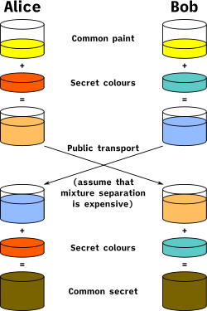
Figure 2.3.1. Simple Example of the Diffie-Hellman Key Exchange Algorithm. Colors are used instead of prime numbers in order to aid in comprehension. To start, Alice and Bob agree on a common color yellow. They both generate a secret color and mix it with yellow. Afterward, they trade their newly mixed color and once receiving the other’s mixed color, mix it again with their secret. The result is the common secret color which can be applied to other colors to encrypt and decrypt them. [19, 28]

The goal of the algorithm is to break the private key into pieces so parts of it can be shared and the actual private key can be built locally. In the example above, we want to mix a certain combination of colors so we end up with the common secret color brown. Brown can then be mixed with other colors to encrypt or decrypt them.

In practice, Diffie-Hellman uses large prime numbers in place of colors. The algebraic methods applied to generate the secret numbers and obtain the private key are similar to those used in RSA. As stated before, ECDH is an extension to Diffie-Hellman but instead of manipulating prime numbers, it uses elliptical curves to generate unique numbers and share the secret key [19]. Therefore, in order to better understand how the ECDH key exchange algorithm works, an overview of elliptical curves is warranted.

2.4 An Overview of Elliptical Curves
An elliptical curve is defined as an algebraic curve that can be represented by equation 2.4.1, where a and b are coefficients and can be chosen at random. [7, 23].

$$y^{2}=x^{3}+ax+b$$
Equation 2.4.1 [7, 23]

In Figure 2.4.1, shown below, I have graphed an example curve using the popular graphing tool Desmos. In this example, a is equal to -2 and b is equal to 3.

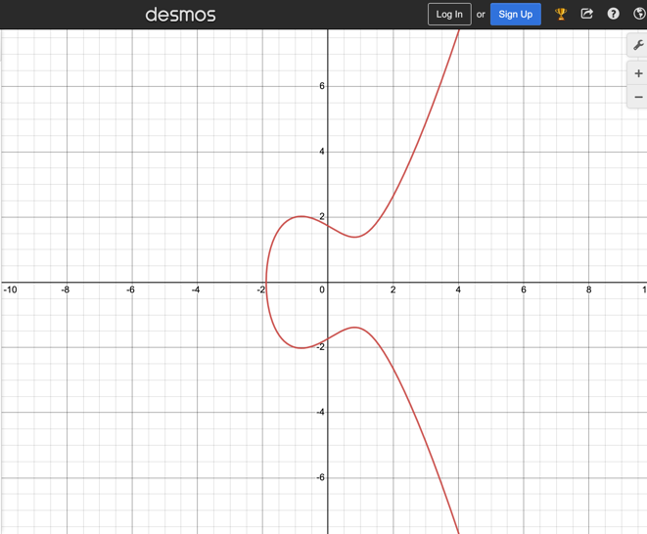
Figure 2.4.1. Example of an Elliptical Curve. Using Desmos, an elliptical curve is graphed where a is equal to -2 and b is equal to 3. [Designed by Author]

Point addition is a fundamental idea of elliptical curves and lays the ground for how elliptical curves are used in cryptography. [18, 27] Using Figure 2.4.2, shown below, assume two points A and B initially lie on the curve. The first step in calculating the sum of A + B is drawing a line through the two points. Where this line intersects the elliptical curve next, is then labeled C. Next, we reflect C over the x-axis to obtain D which is the sum of A + B. All elliptical curves are symmetric over the x-axis; therefore, this reflection process is always valid. [18, 27]

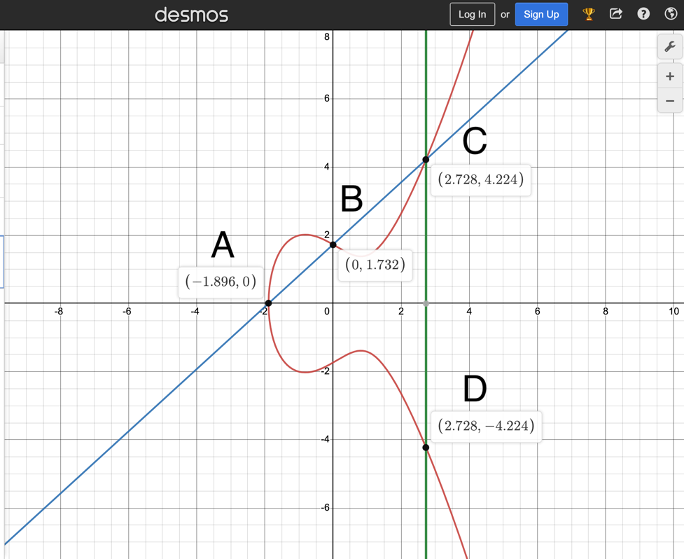
Figure 2.4.2. An Example of Point Addition in Elliptical Curves. Initially, points A and B lie on the curve. To calculate their sum, a line is drawn through the points and intersects the curve at point C. Reflecting C over the x-axis locates a point D which is the sum of A + B.
[Designed by Author]

Point Doubling takes the idea of point addition one step further by utilizing a single starting point instead of two. [18, 27] In Figure 2.4.3, a point G initially lies on the curve and is called the generator point. In order to double G and calculate 2G, a line is drawn tangent to the curve at G. This line then intersects the curve at a point P and reflecting P over the x-axis gives Q. Q is equal to 2G. [18, 27]
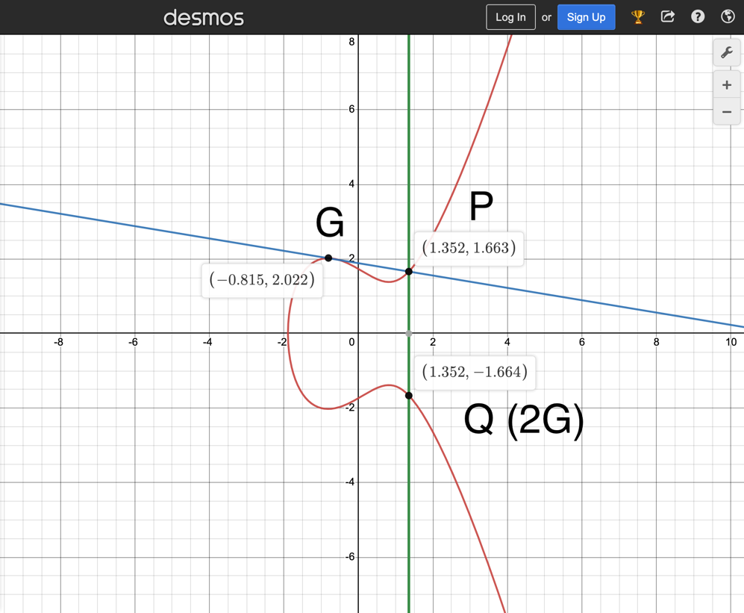
Figure 2.4.3. An Example of Point Doubling in Elliptical Curves. Here G initially lies on the curve and doubling it to obtain 2G starts by drawing a line tangent to the curve at G. This line intersects the curve at P and reflecting P over the x-axis gives Q or 2G. [Designed by Author]

Calculating 3G is an intuitive process as it is simply the point addition of G and 2G. The process to obtain 4G, 5G, … nG is identical. With each new value of n, Q is placed at a new point on the curve and its coordinates grow larger over time. This action of moving Q to seemingly unique locations and letting its values become very large is how cryptographers use elliptical curves to generate random, large numbers for encryption/decryption keys. [18, 27]

2.5 The Elliptical Curve Diffie-Hellman Key Exchange Algorithm (ECDH)
In order to use the ECDH key agreement, both parties must agree on an elliptical curve a generator point. Choosing an elliptical curve means agreeing on its parameters such as the a and b coefficients as well as its upper and lower limits of x and y. [26, 27] Once all of these have been decided, the algorithm mimics the Diffie-Hellman algorithm in procedure.

For example, Alice generates a random, secret number u and Bob generates a random, secret number v. Next, Alice computes uG and gives it to Bob and Bob computes vG and shares it with Alice. Lastly, they each derive the secret key by multiplying their newly received point by their respective secret number. Equation 2.5.1 summarizes how the secret key R is derived in an ECDH protocol. [18, 27]

$$R=u*v*G$$
Equation 2.5.1 [Derived by Author]

Sometimes the x coordinate of R is the secret key that is used in a symmetric encryption algorithm. Other times, it can be the actual message. The significance of the resultant is determined at the start by the parties involved, however, this shows the flexibility of the ECDH protocol. [26, 27]

3. Comparing Analysis of ECDH to RSA

When evaluating an encryption scheme’s overall security, I have a 5 category criteria: amount of memory allocation necessary, difficulty of implementation, key generation time, encryption time and decryption time. Everything except the difficulty of implementation can be analyzed by looking at the key length requirements for each algorithm. Depending on how large a key is, the amount of memory needed to store it and any intermediate values is proportional. [26, 34] Additionally, the computational power necessary will increase exponentially, depending on how complex the math for generating the keys for a particular algorithm is. Finally, using large keys for encryption and decryption will understandably take longer than using smaller keys.

Generally, a large key containing many bits is more secure due to brute force attacks being rendered infeasible. However, a ‘large’ key length is completely subjective based on the algorithm being used. [26] It is very common for algorithms to differ in key sizes necessary to achieve high level security due to how complex each algorithm’s methods are in generating its keys. Taking a look at Table 3.1, the difference in key size requirements between RSA and ECDH is loud and substantial.

Table 3.1. ECDH-RSA Key Size Comparison in Bits [18]

ECDH | RSA
128 | 1024
160 | 2048
192 | 3072
224 | 7680
256 | 15360

The dramatic difference in key sizes leaks into each process’s encryption, decryption and key generation times. In order to measure each performance fairly, both algorithms were tested in the same Amazon EC2 environment and complied using Java. Table 3.2 details key generation with encryption times and Table 3.3 details decryption times. [18]

Table 3.2: RSA-ECDH Key Generation + Encryption Time Comparison (ms) [18] | Table 3.3: RSA-ECDH Decryption  Time Comparison (ms) [18]
  Key Size (b)  RSA:ECDH | RSA | ECDH
  1024:128 | 54.65 | 46.85
  2048:160 | 76.25 | 49.54
  3078:192 | 98.35 | 59.01
  7680:224 | 112.25 | 69.14
  15360:256 | 153.87 | 78.12
  Key Size (b)  RSA:ECDH | RSA | ECDH
  1024:128 | 56.34 | 44.26
  2048:160 | 76.25 | 58.12
  3078:192 | 95.69 | 61.25
  7680:224 | 106.25 | 97.72
  15360:256 | 123.54 | 99.78

As the key lengths increase with higher security requirements, the times for all operations increase steadily however, they increase much slower for ECDH and at the highest security level, ECDH takes half as long for encryption and key generation. Also observe that a scheme that uses ECDH with 256 bits, the highest-level security, has faster decryption time and is only slightly slower in encryption and key generation than a scheme that implements RSA with 2048 bits.

The benefits of ECDH can be further examined by comparing it to another elliptical curve-based algorithm. As stated before, ECDH works best if it is used with a symmetric encryption scheme with the most popular and arguably the best being Advanced Encryption Standard (AES). [17, 20] In a separate study, ECDH and Elliptical Curve Cryptography (ECC) were used to securely facilitate key encryption and distribution while using AES on the backend. Both models, AES-ECC and AES-ECDH, were tested with 5 differently sized text files in order to measure storage necessary, and encryption/decryption times. Tables 3.4 and 3.5 show the results of the analysis with ECDH coming out on top in every single category. [20]

Table 3.4: AES-ECC Storage Allocation & Encryption/Decryption Times [20] | Table 3.5: AES-ECDH Storage Allocation & Encryption/Decryption Times [20]
   | Storage (kb) | Encryption Time (ms) | Decryption Time (ms)
  7650 kb | 23115 | 140 | 20
  152135 kb | 456555 | 218 | 59
  581469 kb | 1744539 | 78 | 96
  2878 kb | 8763 | 16 | 22
  4106 kb | 12459 | 13 | 6
   | Storage (kb) | Encryption Time (ms) | Decryption Time (ms)
  7650 kb | 13811 | 17 | 7
  152135 kb | 275527 | 37 | 27
  581469 kb | 1057809 | 57 | 54
  2878 kb | 5217 | 10 | 3
  4106 kb | 7447 | 11 | 4
The results reflect that AES-ECDH takes less computation time to convert each file into a ciphertext and get it back to its original format. The storage parameter signifies how much memory is necessary to store each converted file and is measured in kilobytes. Based on the results, AES-ECDH is clearly better in terms of storage than AES-ECC. [20]

The one true advantage RSA has over ECDH is that it is easy to implement in practice. RSA has been around since 1977 so there are numerous of professional examples of it being used in practice. One does not need to be a master cryptographer in order to understand the algorithm and then follow a guide that has already been established on how to use it. [26, 33, 34] Elliptical curves are still fairly new and are continuing to be researched. The mathematics behind elliptical curve cryptography are so complex that an advanced cryptographer, or at least an intermediate one, would need to be developing the system in order to get the true benefits out of the curves. [8, 16] And because elliptical curves haven’t been around for decades, there are not an ample amount of industry examples of them being used in order to aid in a lack of full comprehension. However, I am sure there was a similar situation when RSA was first introduced. In time, cryptographers will begin to adopt elliptical curves more frequently and ECDH will become easier to use in practice.

Based on the results of this comparative analysis, ECDH is the obvious pick when it comes to memory consumption, key generation, encryption and decryption. Since all of these factors would incur cost in a cloud-based system, ECDH would be the cheaper option compared to RSA. Additionally, due to these key advantages, ECDH can provide higher security for equal cost and time necessary. Although ease of implementation is a considerable drawback, the security benefits cannot be ignored and ECDH should be considered if storage and computational power are the utmost concern. [18, 20]

4. Factorization Attacks on RSA

When it comes to evaluating security schemes, analyzing current methods to break them should also be analyzed. The most common attacks on an RSA cryptosystem come in the form of factorization attacks. [14] These attacks work by factoring the value n into its p and q values which are used to find phi(n). Once phi is known, a malicious actor can use equation 2.2.2 to derive the decryption key, d. [14, 22] This is why the keys of RSA must to be very large. If n is 100+ digits long, then there are millions of possible values for p and q which increases the amount of time needed to break the algorithm.

Currently, the General Number Field Sieve (GNFS) algorithm is the best method for cracking an RSA cryptosystem using keys 100+ digits long. [5, 22] In 1998, GNFS successfully factored a 130-digit key which at the time was the largest number ever factored. [30] More recently in February 2020, an 829-bit or 250-digit RSA challenge number was broken. Although these records are very impressive, the amount of computing power necessary is not common amongst regular criminals. For example, back in October 2014 when a 210-digit key was broken, it required $7600 of AWS computing power and took about 20 months to complete. [30, 32]

As advancements continue to be made the security of RSA is coming into question and many predictions state that RSA could be rendered unsafe to use by the end of the decade. [8] What took 4 months back in 2002 to factor a 155-digit number, would probably only take a couple of weeks today.

5. Breaking Elliptical Curves: The Discrete Logarithm Problem

In order to break a scheme secured with elliptical curves, it requires solving the discrete logarithm problem. In equation 7.1 below, a value for k that makes the equation true is deemed the discrete logarithm of a to base b. [29]

$$b^{k}=a$$
Equation 7.1 [29]

For example, the discrete logarithm for the problem $3^{k}=9$ is 2. This problem’s difficulty grows exponentially for every digit added to the a and b. For example, what is the value for k if the problem is ${193847812394902392380423984}^{k}=747182929192020102988….$?

In terms of elliptical curves, the discrete logarithm problem is just as difficult but becomes more visual. Refer to Figure 5.1 for detail. Take two known points, G and Q, that lie on the curve. The goal now is to solve the problem nG = Q or how many times G was multiplied to get Q. [21]
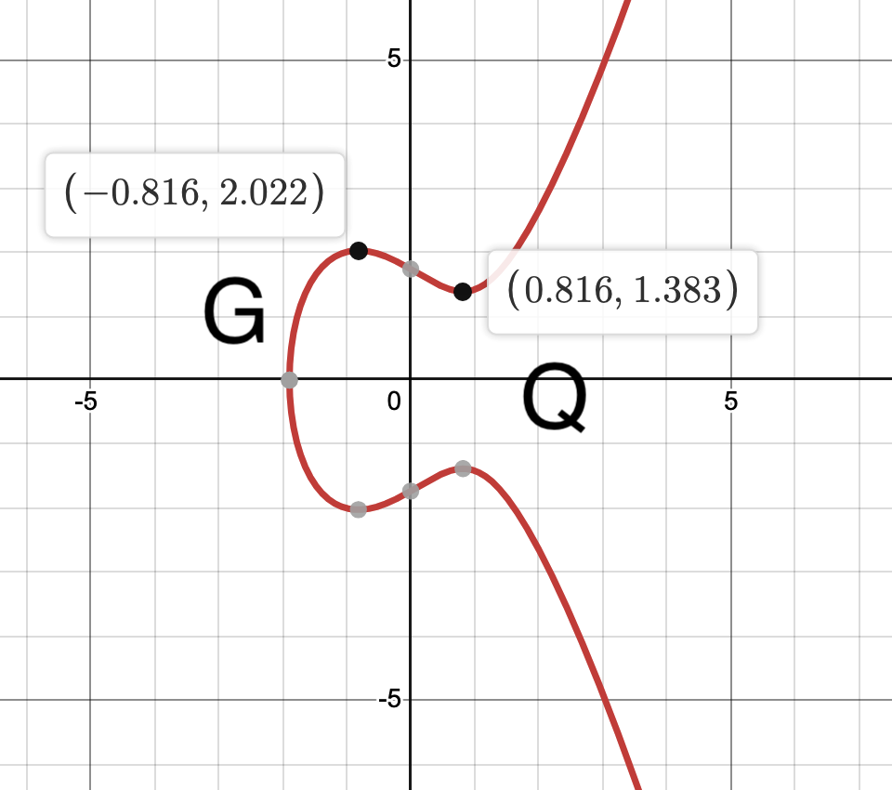
Figure 5.1. Example of the Discrete Logarithm Problem in Elliptical Curve Cryptography. If given two points, G and Q, that lie on the curve, the goal is to find how many times G was multiplied to arrive at Q. [Designed by Author]

Again, this can be made easy if G and Q are close to each other which would mean n is relatively small. Therefore, it is necessary for n to be large, however, it doesn’t need to be as large as an RSA key because the discrete logarithm problem is much harder to break than factoring large numbers. [21, 29]

Pollard’s Rho is an example of an algorithm that has been designed to compute discrete logarithms. As of 2004, Pollard’s Rho can successfully crack 109-bit long curves, however this took 17 months and is very far from cracking even the smallest of elliptical curves used in practice. [8] It is estimated that Pollard’s Rho would take $5 × {10}^{13}$ months to break one of the smallest curves. [8] Since elliptical curves are still being researched themselves, there are not many options one could use to break them and the ones that exist are still very far away from being a threat to these cryptographic schemes.

6. Conclusion

RSA has been a popular encryption protocol in security systems for a few decades. Its simplistic nature and ease of implementation makes it a go to for many companies. However, the benefits of RSA when compared to ECDH end here. ECDH has faster key generation, encryption and decryption methods, consumes less memory and is overall a harder algorithm to break due to the inherent difficulty of the discrete logarithm problem.

ECDH does not just top RSA in these 5 major categories, it also competes with many other elliptical curve-based algorithms. When compared to ECC, ECDH is better in terms of computation speed and is able to deliver more compact ciphertexts utilizing less storage space. ECDH requires some of the smallest keys in cryptography and is what makes it a very strong protocol. While elliptical curves are difficult to master and use in practice, this can be viewed as a benefit as well. There are no real threats to a security system that employees them because algorithms used to solve discrete logarithms are still being researched too.

Based on my research, the security potential of ECDH is at an all-time high right now. If implemented correctly, a system could be secured for a very long time and therefore, I must recommend ECDH for cloud security. While data breach attempts are inevitable, ECDH is one of the best mitigators and encryption schemes for long-term security.

Glossary

Amazon EC2: Amazon EC2 is short for Amazon Elastic Compute Cloud and is a cloud service provided by Amazon that allows users to rent virtual computers on their platform.
AWS: AWS is short for Amazon Web Services which is a popular cloud platform used by many companies worldwide.
Asymmetric Encryption: A class of encryption where a public key is distributed and used for encryption and a separate private key is held by authenticated personnel only and is used for decryption.
Big Data: Very large sets of data that are continuously growing and need specialty software in order to analyze and digest.
Brute Force Method: A simple, yet inefficient, method used to achieve a goal.
Cloud Computing: An internet-based computing where virtual shared servers provide software, infrastructure, platform, devices, and other resources.
Ciphertext: Scrambled, unreadable text derived from applying an encryption scheme to some plaintext.
Java: A popular high-level programming language.
Symmetric Encryption: A class of encryption where a single key is generated and used for encryption and decryption.
Key Exchange Algorithm: An algorithm designed to securely facilitate the sharing of private information, most often private decryption keys.

